**FPT ACADEMY INTERNATIONAL**

**FPT**

**–**

**APTECH**

**COMPUTER EDUCATION**



**Centre Name: ACE-HCMC-2-FPT.**

**Address: 590 Cach Mang Thang 8, District 3, Ho Chi Minh City, Viet Nam.**

THE CAKE

|  |  |  |
| --- | --- | --- |
| **Supervisor** | PHAM THI LANH |  |
| **Term:** | 1 |  |
| **Batch No** | T1.2008.M0 |  |
| **Group No** | 1 |  |
| **Order** | **Full name** | **Roll No.** |
| 1. | NGUYỄN HẠ VY | Student1273518 |
| 2. | PHẠM VĂN NGUYÊN | Student1273001 |
| 3. | PHẠM VĂN QUANG | Student1272807 |

Month 10 Year 2020

**CONTENTS**

ACKNOWLEDGEMENT 3

SYNOPSIS 3

REVIEW 1 4

REQUIREMENT SPECIFICATION 5

PROBLEM DEFINITION 7

CUSTOMERS REQUIREMENT SPECIFICATIONS (CRS) 8

ARCHITECTURE & DESIGN OF THE SYSTEM 10

SITEMAP 11

WEBSITE LAYOUTS 11

1. Homepage: 12

2. Informative pages: 15

TASK SHEET 1 15

REVIEW 2 16

THE CAKE 17

1. Homepage 17

2. Contact Us page 20

3. Products page 22

4. Order form page 22

5. Cart 23

6.Event page 25

5. Footer 26

TIME MANAGEMENT 27

TASK SHEET 2 28

# ACKNOWLEDGEMENT

# SYNOPSIS

Cambridge Hospital is one of the famous hospital in the town since 1928, now the hospital organization wish to change their existing website completely. The website which they demand is suppose to provide user friendly environment and navigation.

The important menu must be stated in the top section of the webpage. Also a decent look out and color combination is expected.

The website is to be developed for the Windows Platform using HTML5, JavaScript and Geolocation. The site should work well in all leading browsers including Chrome, IE, Firefox..

# REVIEW 1

# REQUIREMENT SPECIFICATION

**The Web site is to be created based on the following requirements.**

1. **Home page:** The page should be designed with a banner at the top of the page. The home page should cover a brief description of the entire website / presentation as well as a brief history of cake.
2. **About us:** divide the page into three sections vertically. Provide the, mission and vision on these sections.
3. **All products:** the product page should be designed with all the products / thumbnails along with brief details of the individual products, such as
   1. item code
   2. Price
   3. Egg less/with Egg
   4. order button
4. On click on the order button a purchase form page should appear on a new browser window. The purchase form page should have all the form fields to capture the entire transaction and the users' details like
   1. Name
   2. Address
   3. Contact number
   4. Item code
   5. Quantity
   6. Delivery address
   7. Delivery Date
5. On click on the zoom button an enlarged image of the same product should appear on a new browser window.
6. **Products by event:** provide a categorized sub-navigation on this page such as
   1. Birthday
   2. Anniversary
   3. Engagement
   4. Marriage and so on.

Each and every sub-navigational button should be linked to an individual page. All the individual page should be designed with selected / categorized thumbnails along with brief details of the individual products, such as item code, price, zoom and order button.

1. On click on the order button a purchase form page should appear on a new browser window. The purchase form page should have all the form fields to capture the entire transaction and the users’ details.
   1. Name
   2. Address
   3. Contact number
   4. Item code
   5. Quantity
   6. Delivery address
   7. Delivery Date
2. On click on the zoom button an enlarged image of the same product should appear on a new browser window.
3. **Site Map:** The site map page should contain the entire navigational structure / diagram in a visual form and all the links (page names) of the diagram should be programmed for hyperlink to the respective pages.
4. About us, Contact Us, Disclaimer must be included. “Contact Us” page should have the Address of the Company and the mail address which when clicked will invoke the local mail client from where they can send an email. Address of the Company should be displayed using GeoLocation API (eg. GoogleMaps)
5. Creating an account facility can also be added.
6. Dummy procedure for buying to be added.

# PROBLEM DEFINITION

After reading the project specifications, the developer states the scope of the project very briefly. This is referred to as the problem definition. Queries of various staff members can be one or all of the following:

1. How many products can be displayed on Homepage at a time?

1. What information should be displayed about each product in Homepage?

1. Will users be able to contact the web site when they have any demand?

1. Will the users be able to feedback their opinions?

1. Will the users be able to question about The cake shop’s services?

After consulting several IT companies and considering the budget constraints, the management of The Cake to launch the Web application as a single page responsive Web application using HTML5, CSS3, JavaScript, Geolocation API, Web Storage, AngularJS, and Bootstrap 3.3 from getbootstrap.com, jQuery plugins, and Coffee Cup, Notepad++, or other HTML editor. Also, the site will be tested on popular browsers and mobile emulator software.

# CUSTOMERS REQUIREMENT SPECIFICATIONS (CRS)

**1.Client: THE CAKE**

**2.Business/Project Objectives:**

* Provide a website to displays the programs and services about the cake shop such as: “About us”, “Products”, “Event”, “History”, “Vision”,

“Contact Us”, “Feedback”…

* Enable customers to see what event that they would like. Easier interactive with us.

**3.Inputs provided by clients:**

Inputs to the existing system.

Outputs from the existing system.

Process involved in the application.

Expected delivery dates.

List of deliverables.

**4.Hardware Requirement:**

* A minimum computer system that will help you access all the tools in the courses is a Pentium 166 or better
* 64 Megabytes of RAM or better

**5.Software Requirements:**

* Notepad/HTML editor
* Dreamweaver
* IE 5.0/ Netscape 6.0

# ARCHITECTURE & DESIGN OF THE SYSTEM

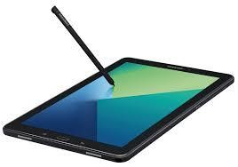

**CLIENT**

**SERVER**



Font End technologies

(

HTML5, CSS3, Bootstrap, jQuery

)

# SITEMAP

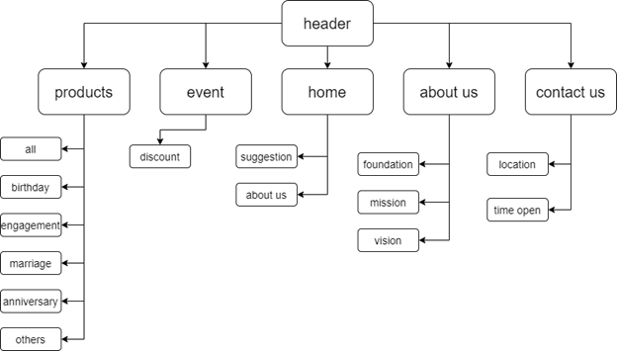

# WEBSITE LAYOUTS

**Here are our layouts which will show you how we brainstormed ideas for the The Cake’s web pages. Because of being Sales website, we tried to build them SIMPLE but USEFUL and INFORMATIVE as much as possible.**

**The website is going to have several pages which include different information in the same main layout.**

## 1. Homepage:

This layout below describes how we created our Homepage which contain three important parts:

* *Page-header and Navigation bar:*

Page-header must have The-Cake’s logo and other links like contact us, account. Search bar is optional.

Navigation bar is one of the most crucial sections in the whole website which will indicate people how they interact with us. It provide some information like Home, About us, All products, Contact us, Event. Each section must have brief information.

* *Content:*

This part is customized belong to the title of the individual websites, especially Homepage with some descriptions about The Cake Shop history and its summary development throughout the years.

* *Footer:*

The final part of all our websites is definitely Footer which will reveal some convenient ways to contact the shop in different social channels like Email, Facebook …

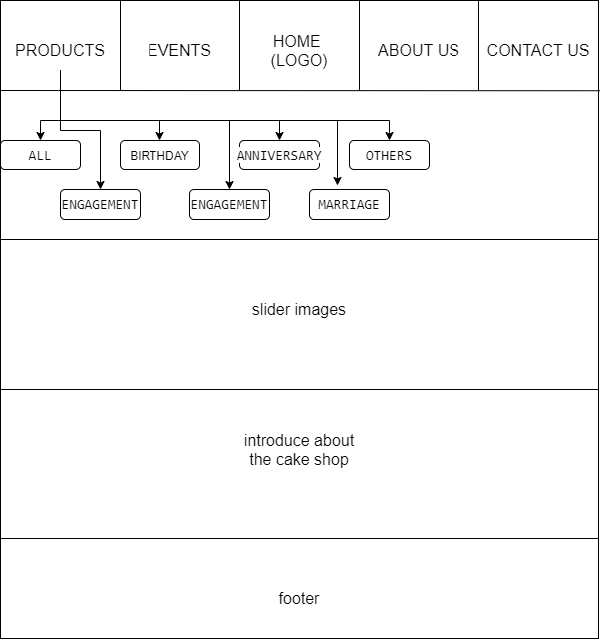

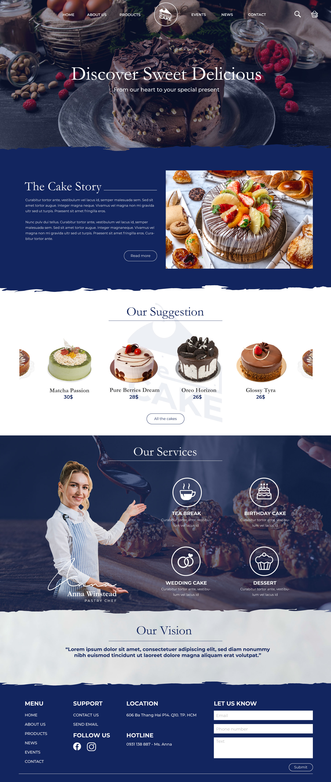

## 2. Informative pages:

This layout we will apply for most of other pages (Contact us, Feedback, Query...) which provide people different information about the Cambridge hospital. It also has the same Page-header, Navigation bar and Footer as Homepage, but the main content is changed. Interestingly, we will design additional sidebar with class “active” to help people enter another related website easier.

# TASK SHEET 1

|  |  |  |  |  |  |  |
| --- | --- | --- | --- | --- | --- | --- |
| **Project Ref. No.** | **Project Title** | **Activity**  **Plan**  **Prepared by** | **Date of Preparation of Activity Plan** | | | |
| **Task** | **Actual Start**  **Date** | **Actual**  **Days** | **Teammate**  **Names** | **Status** |
| Create layouts for website base on group discussion ideas | THE CAKE SHOP | Vy | 18/10/2020 | 2 | Vy,Văn, Nguyên | Completed |
| Draw layouts using  Photoshop | THE CAKE SHOP | Vy | 20/10/2020 | 2 | Vy | Completed |
| Write project  report 1 | THE CAKE SHOP | Vy | 17/10/2020 | 4 | Vy | Completed |
| Homepage design and coding  (include navigation bar and footer) | THE CAKE SHOP | Vy | 19/10/2020 | 7 | Vy,  Nguyên | Completed |

# REVIEW 2

# THE CAKE

## 1. Homepage

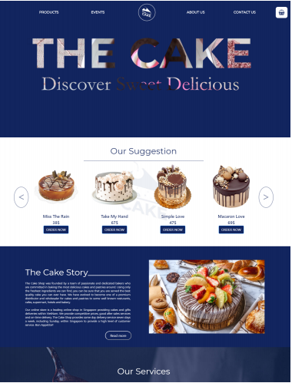

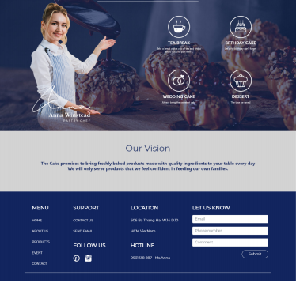

When patients and visitors hover the navigation bar, a menu bar will appear with its links as you see above picture.

|  |  |
| --- | --- |
| **Title** | **Description** |
| Contact us | * The cake shop’s address with map, main contacts. * Creating an account facility can also be added. |
| Icon The Cart | * The customer can check their option. * The shopping cart stores all product pages. * The customer can delete or add product quantity. * The total amount payable will also be presented. |
| Home | * Carousels which show some highlights the good cake. * Introduction about the cake shop: story, service, vision. * Some other news and upcoming events to update latest information people concerned. * Footer with different ways to contact us and some comment about The Cake. * The video about the cake on the first section. |
| About us | * Our story: detail about The Cake * Our chef, Feshness & Quanity, Joyfull Experience, Global Presence. |
| Event | * Let’s us sweeten your Christmas: event about the date for couple. * New arrival: the new menu. * Basic course: the course for beginer. * Junior baker contest: the competition for the kid. * The art of dessert workshop: workshop about design cake * Discount: customer type code to get discount * Travel with your taste of bus: a meal serv on bus * The custumer must be contact to the cake shop for more information. |
| Products | * “Our suggestion”: highlights the good cake, best sale. * Sub-navigational bar: Birthday, Anniversary, Engagement, Marriage, Other. * When the visitor hover to the image of the cake, the detail information wil be appear. * When the visitor clip to the zoom icon in the detail information, an enlarge image of the same product appear on a new browser window. * When the visitor clip to the cart icon, a table-cart wil be appear with the price, quantity, image of the cake. * In the table-cart, the customer can delete or augment the cake. * In the table-cart, the customer can type code to get discount. Ex: “SALE40” discount40%, “SALE20” discount 20%. * The customers can Order now or choose a variety of products. |

## 2. Contact Us page

When you click to Contact Us link in the Homepage, this page below will show you map to the cake shop with Geolocation API and main contact information.

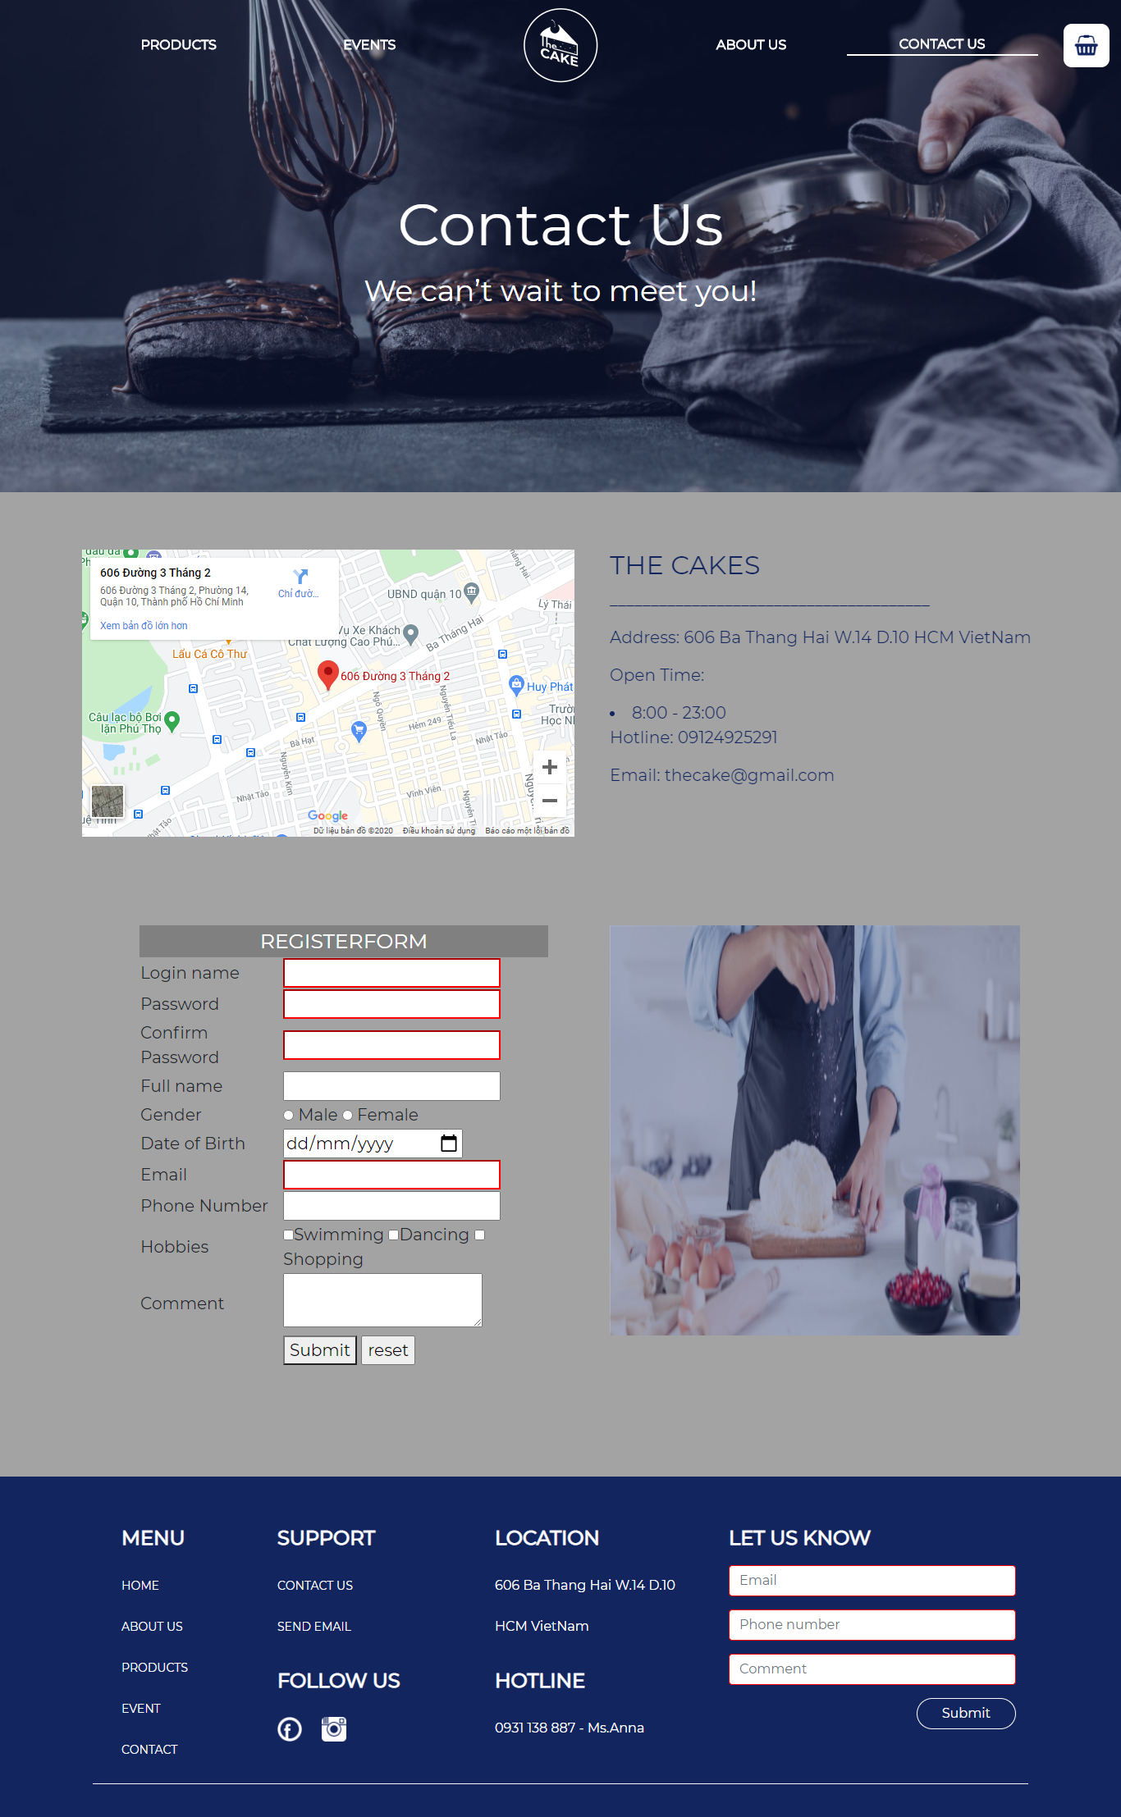

## 3. Products page

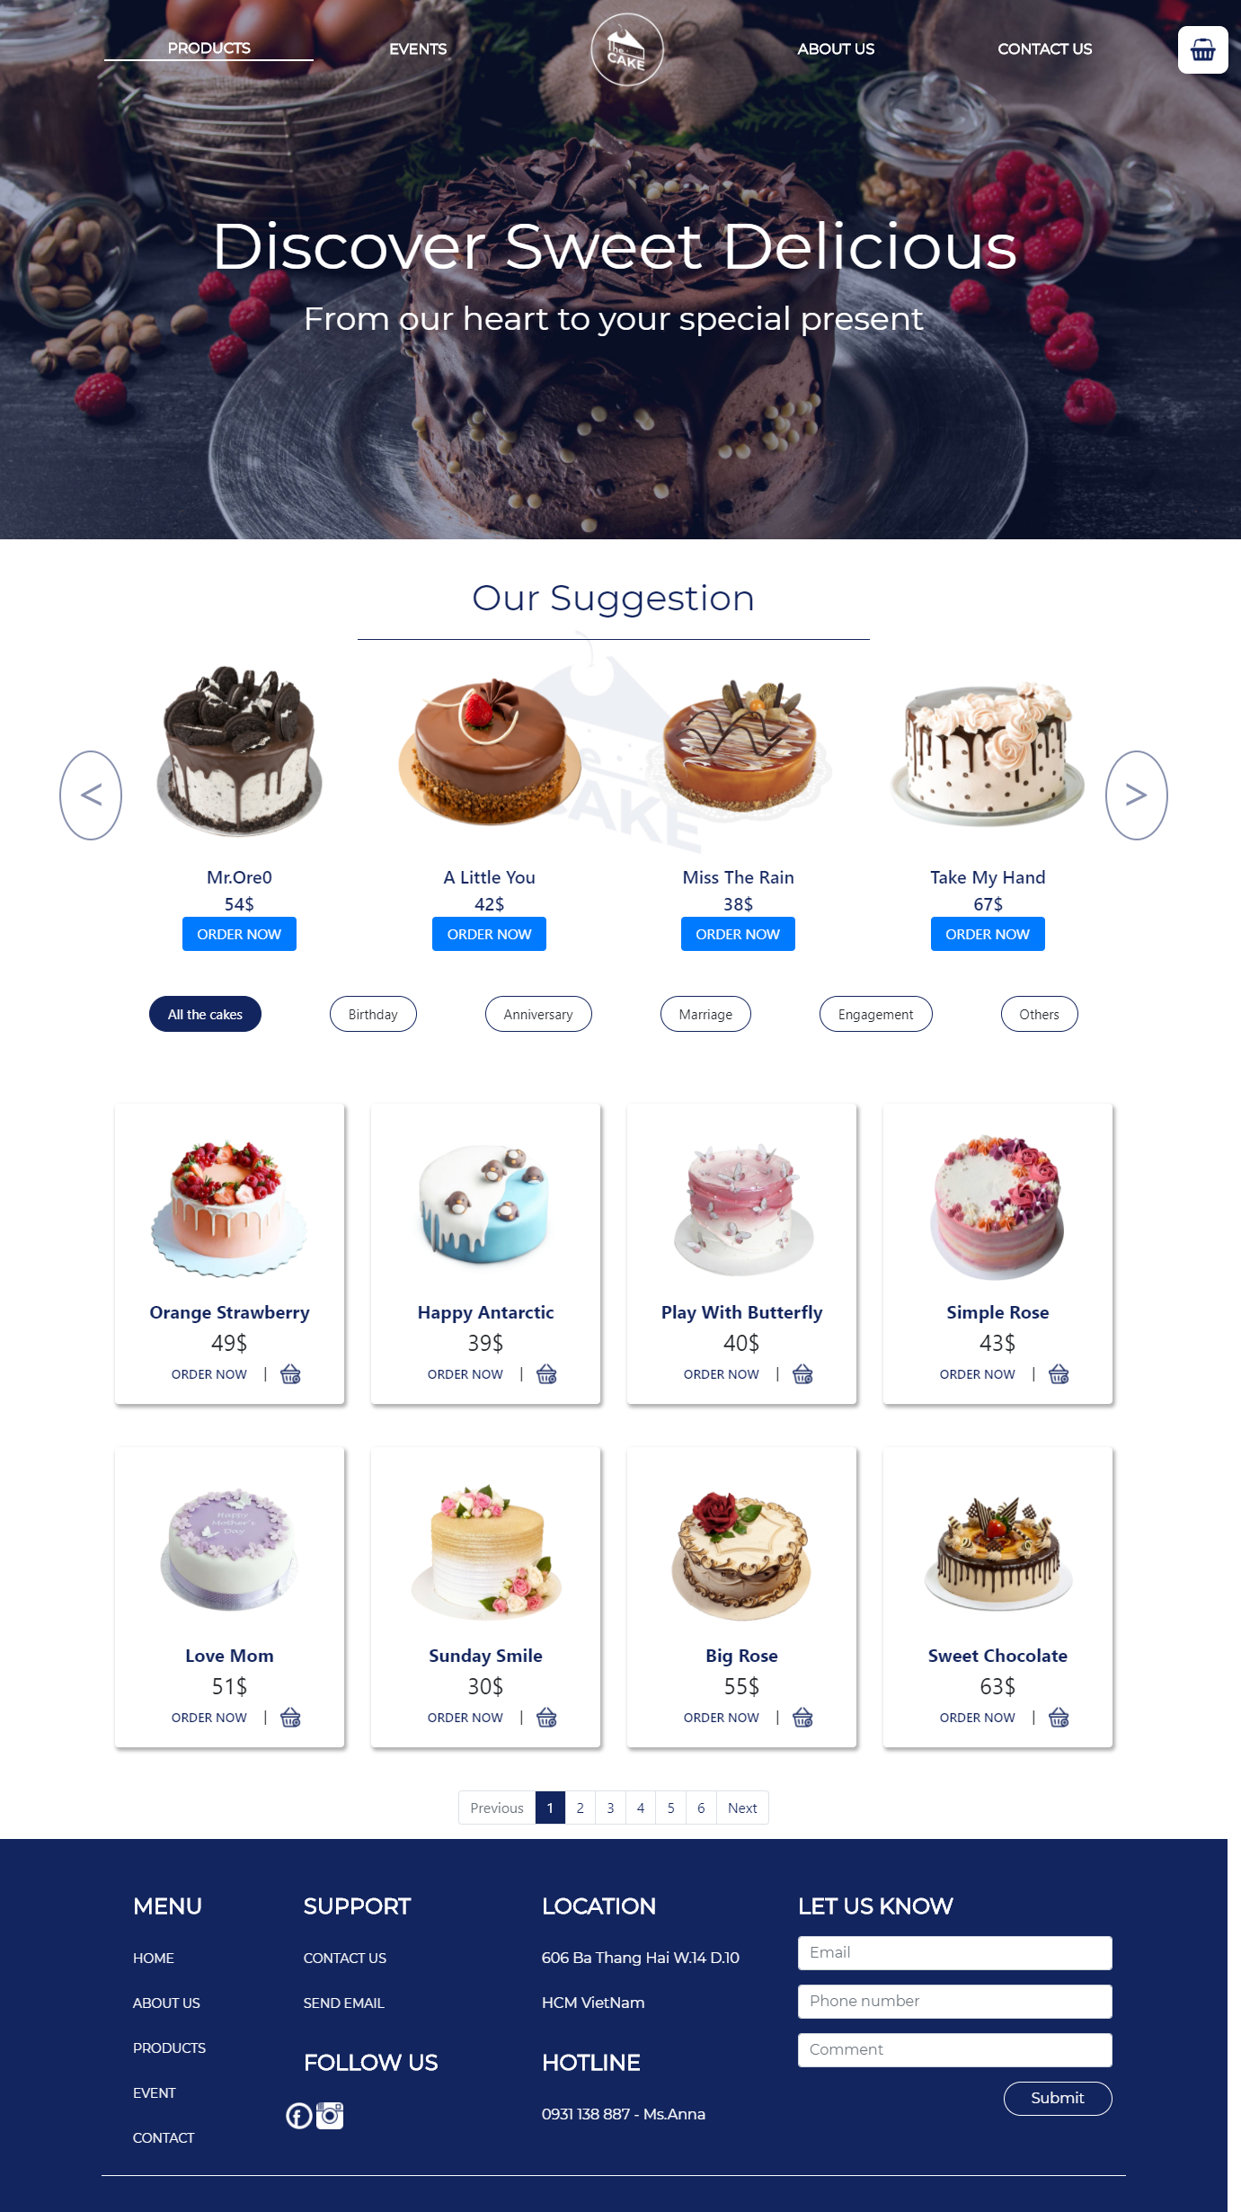

## 4. Order form page

When you click to “ORDER NOW” button, this page below will show you the form. You fill full to get the delivery service.

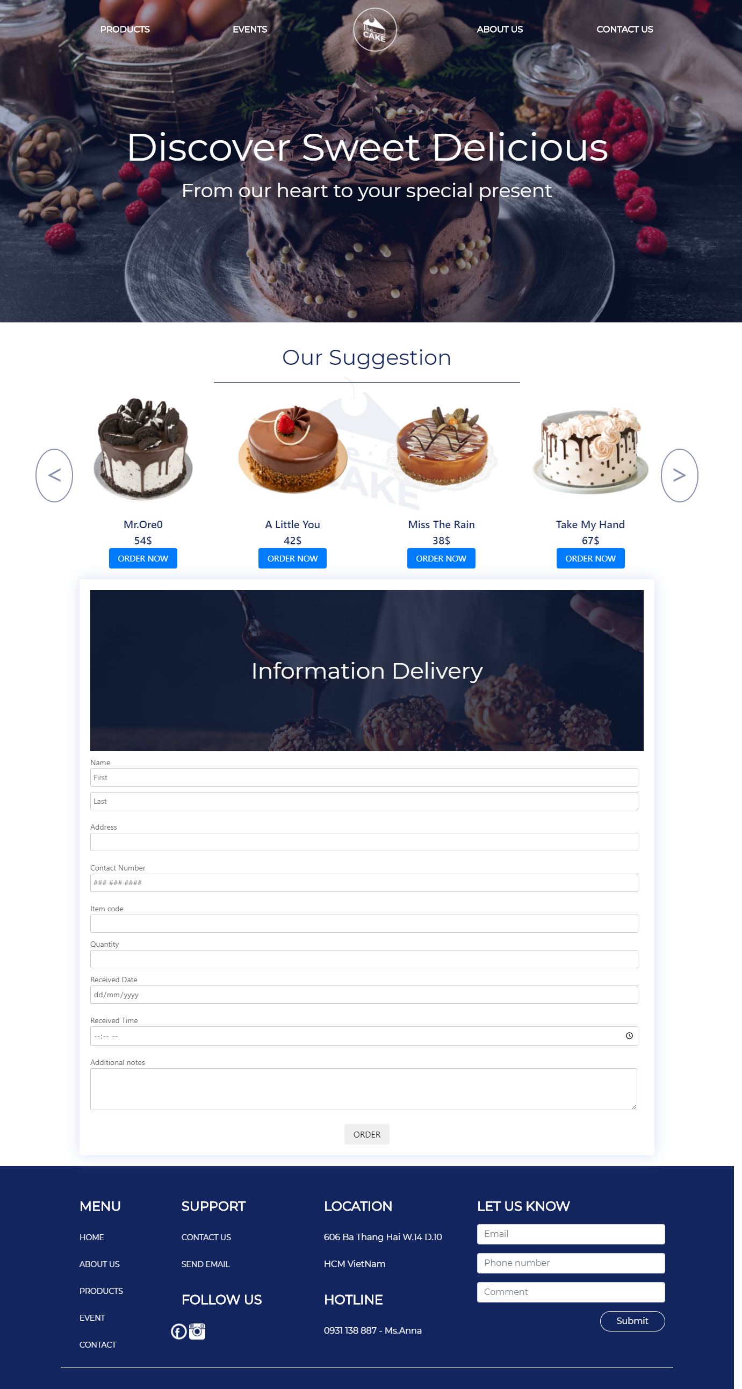

## 5. Cart

By clicking icon cart button, the cart will appear.

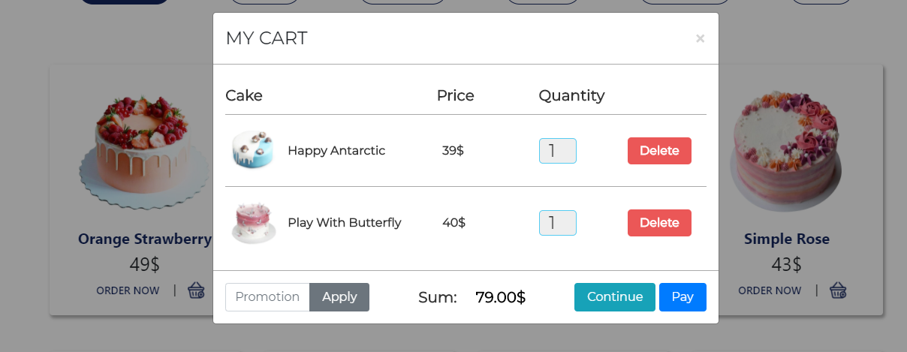

## 6.Event page

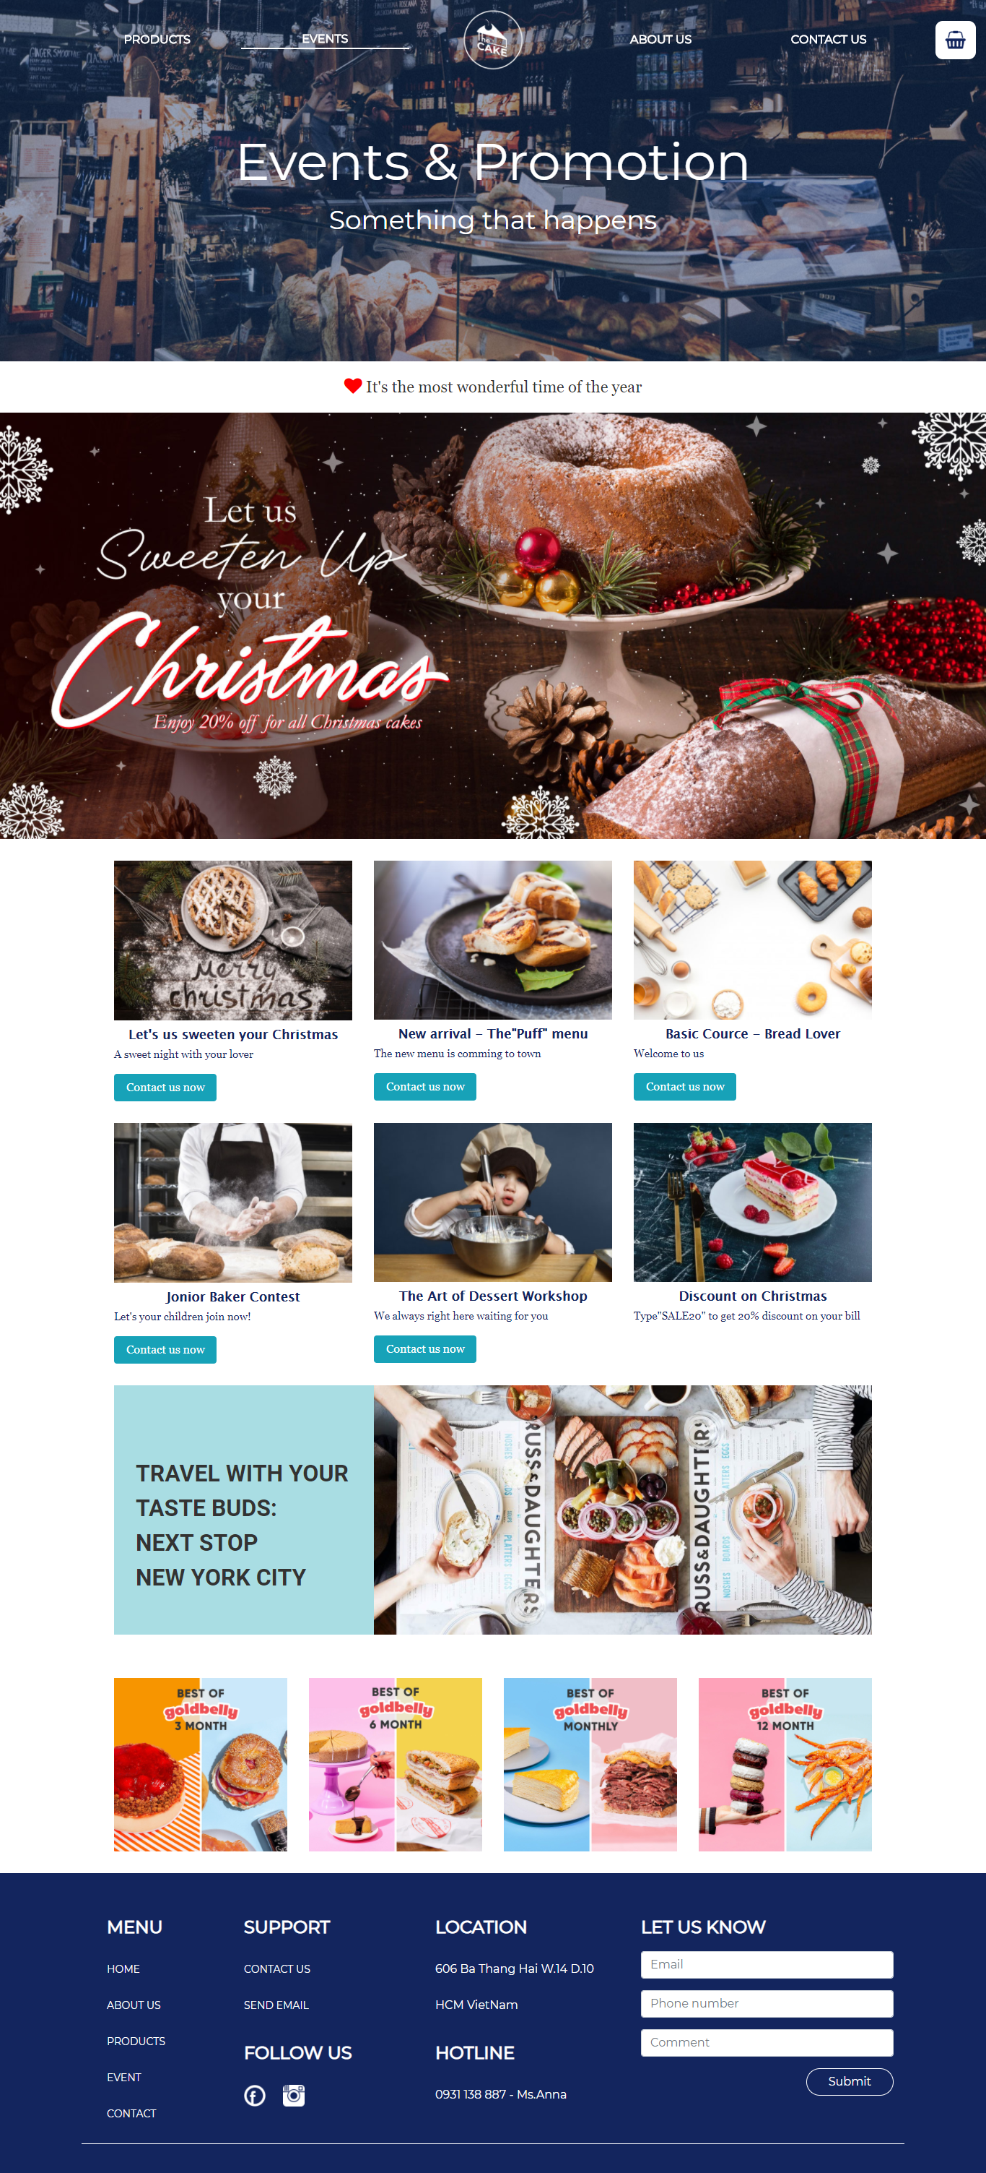

The customer can join workshop, competior, the course or find discount codes

## 5. Footer

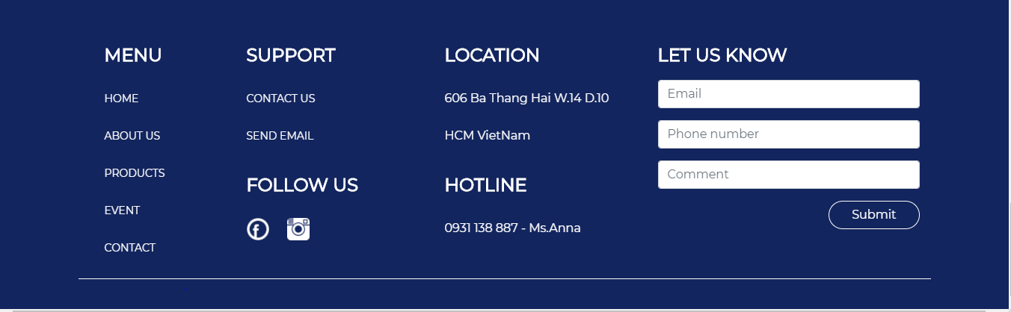

By clicking “Send Email” button, the new window is created which have the cake shop’s email address and subject already. The customer can also leave comment.

# TIME MANAGEMENT

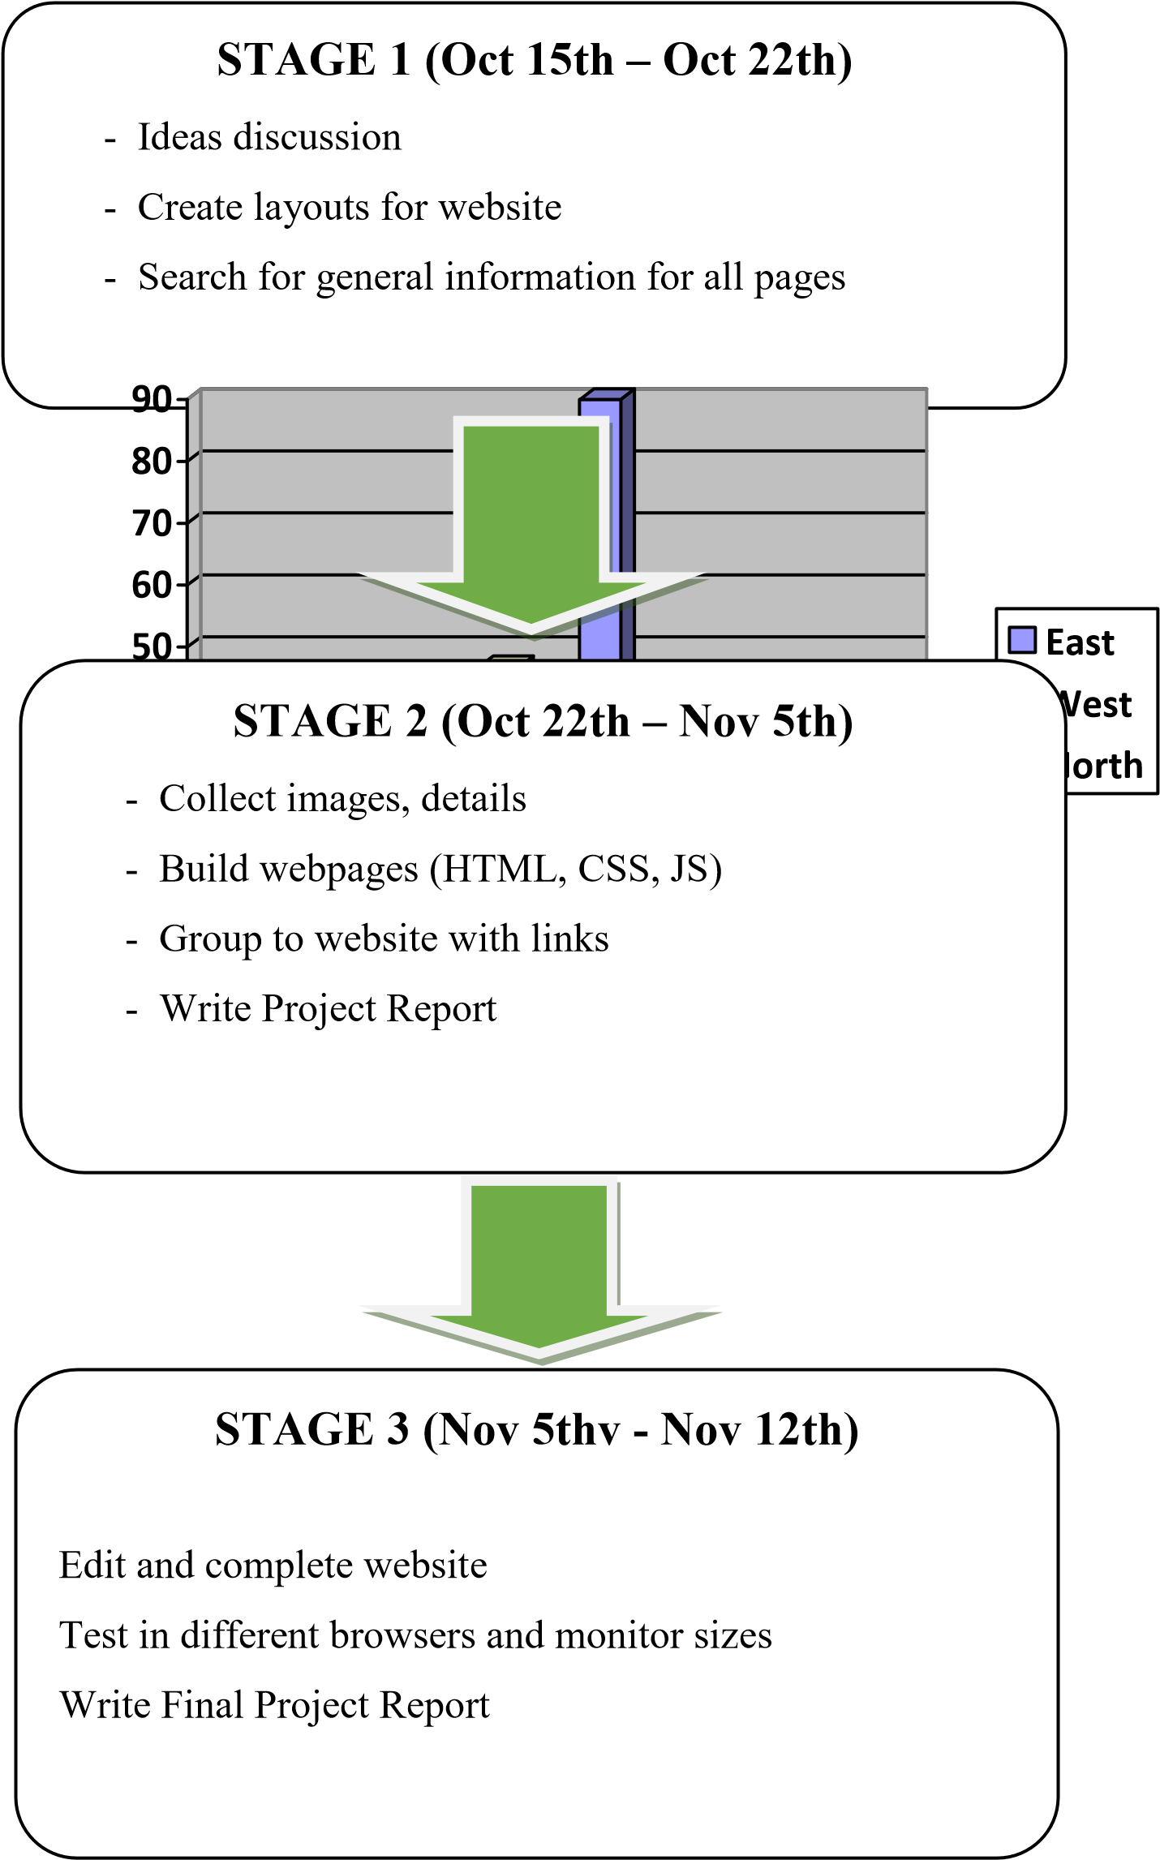

# TASK SHEET 2

|  |  |  |  |  |  |  |  |
| --- | --- | --- | --- | --- | --- | --- | --- |
| **Project Ref. No.** | | **Project Title** | **Activity**  **Plan**  **Prepared by** | **Date of Preparation of Activity Plan** | | | |
| **Sr.**  **No** | **Task** | **Actual Start Date** | **Actual**  **Days** | **Team mate**  **Names** | **Status** |
| 1 | Design Contact Us page and coding  (include Geolocation  API) | THE CAKE SHOP | Vy | 25/10/2020 | 2 | Vy,  Nguyên | Completed |
| 2 | Design Home page and coding | THE CAKE SHOP | Vy | 30/10/2020 | 3 | Vy,  Nguyên | Completed |
| 3 | Design Event page and coding | THE CAKE SHOP | Vy | 1/11/2020 | 2 | Vy,  Quang | Completed |
| 4 | Design Products pages, footer, nar bar, orther form page, “our suggestion” carousel and coding. | THE CAKE SHOP | Vy | 24/10/2020 | 20 | Vy | Completed |
| 5 | Search image | THE CAKE SHOP | Vy | 24/10/2020 | 7 | Vy | Completed |
| 6 | Group pages together with links and update information | THE CAKE SHOP | Vy | 9/11/2020 | 10 | Vy | Completed |
| 7 | Test website in  different browsers | THE CAKE SHOP | Vy | 5/11/2020 | 5 | Vy | Completed |
| 8 | Draw site map | THE CAKE SHOP | Vy | 10/11/2020 | 3 | Vy | Completed |
| 9 | Write project  report | THE CAKE SHOP | Vy | 10/11/2020 | 3 | Vy | Completed |

|  |  |
| --- | --- |
| Signature of Faculty | Signature of Leader Team |
|  |  |